Current Operable Unit 3 Phase III Remedial Progress for Week Ending 9/10/10
Creamer Environmental Inc., National Grid’s Remediation Contractor, has completed the excavation portion of the project. The excavation area was located adjacent to where the LIRR tracks were previously relocated. To date, 149 trucks have transported approximately 4616.86 tons or 3077.91 cubic yards of soil to Bay Shore Soil Management (BSSM, formerly ESMI of NJ) for thermal desorption.
GEI, National Grid’s Remediation Oversight Consultant, continues to perform Community Air Monitoring Program, which will continue throughout the project.

Two-Week Outlook
Creamer Environmental Inc., will continue the load-out of impacted soils from the temporary fabric structure (TFS). This work is expected to continue into next week. Additionally, restoration (which includes sub-grade and final grade restoration) is also progressing and will continue for the next few weeks. Lastly Creamer has started and will continue the demobilization of all non essential equipment and temporary facilities brought to the site to complete the remediation.
General hours of operation will continue to be Monday through Friday, 7:00 AM to 3:30 PM. However, work hours will be extended when necessary to maintain schedule or to complete critical tasks.
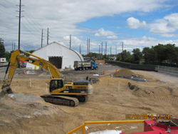
Installing sub grade material
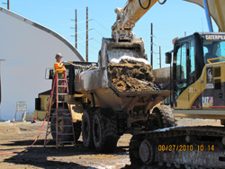
Applying odor suppression foam to site haul truck
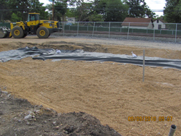
Installing demarcation barrier

